Serverless Compute (Functions & Logic Apps)
Hands-on:
- Trigger Function on payment event
- Send SMS/email using Logic Apps
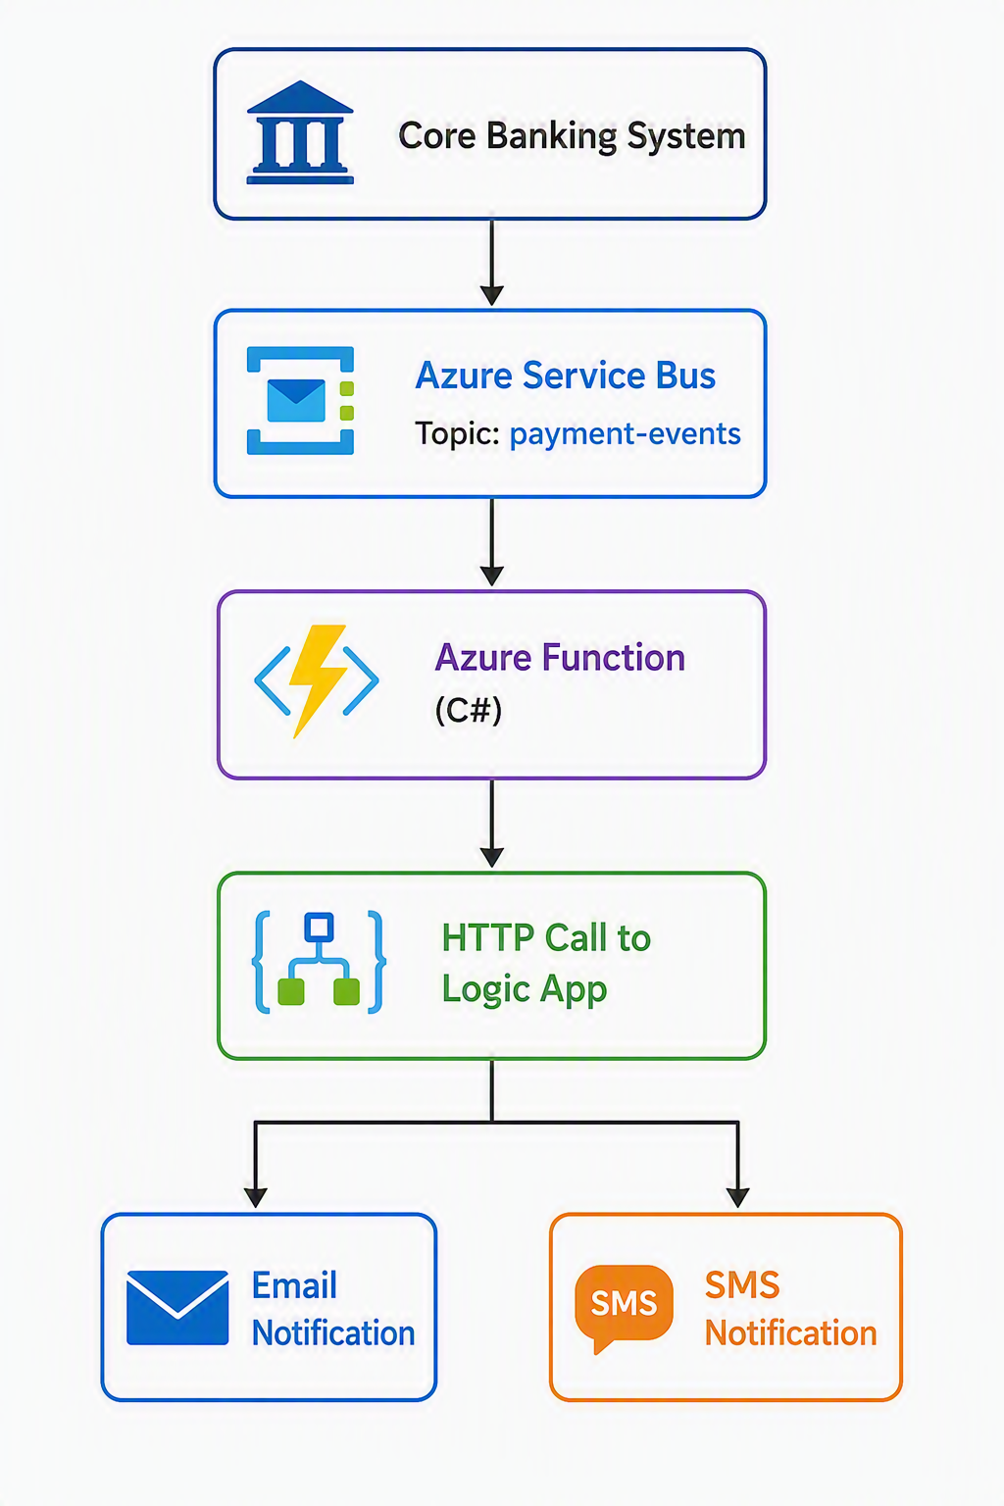
Assignment:
Trigger notifications after transactions
Eventing & Streaming
- Azure Event Grid
- Azure Event Hubs (real-time ingestion basics)

